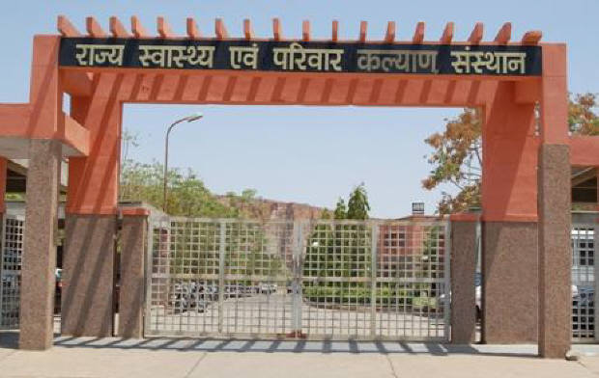
SIHFW Rajasthan

Electronic Newsletter
July to October 2025 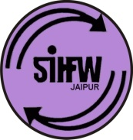
SIHFW: an ISO 9001:2015 certified Institution
From the Director’s desk…
Dear Friends…

Wishing all readers a very Happy New Year! This year in month of November, we bid farewell to our Director sir Dr S.S. Agrawal, and it was a moment to celebrate his superannuation. There was a grand party at office, and some very good messages director sir reflected for youngsters. He shared many glimpses of his experiences of working as a Medical Officer and posted at village level PHC and challenges faced by him and his family members also. But, the new generation must learn to work with dedication.
That;s why on behalf of our director sir, we are sharing this editorial in last issue of e newsletter for the calendar year 2025. However, the trainings will continue in 2026 as per the financial year 2025-2, hence the progress presented in this newsletter is not the final annual progress. We will share more updates in next e newsletter.

As public health sector professions, we all must pledge to celebrate this New Year, with a concern for each other’s health and ensuring a safe environment to animals and birds too. So that the spirit of this New Year is celebrated in its true sense of enlightenment, well wishing and gratitude.

Best Wishes!!

Dr. Pushpa Chaoudhary
Registrar-SIHFW

Some important health and social days for July to October 2025
1 July-Doctors’ Day | 27 September –World Retina Day (Last Saturday of September)
11-July-World Population Day | 26 September –World Contraception Day
22 July-World Brain Day | 28 September-World Rabies Day
25 July-World IVF Day | 28 September- World Deaf Day (Last Sunday of September)
28 July-World Hepatitis Day | 29 September-World Heart Day
1 August –World Lung Cancer Day | October 1-31: Breast Cancer Awareness Month
3 August-Indian Organ Donation Day | October 12: World Arthritis Day
1-7 August- World Breastfeeding Week | October 13: International Day Of Disaster Reduction
13 August-World Organ Donation Day | October 15: Global Hand washing Day
13 September –World First Aid Day  (Second Saturday of September) | October 16: World Food Day/World Anesthesia Day
10 September-World Suicide Prevention Day | October 20: World Osteoporosis Day
21 September –World Alzheimer’s Day | October 24: World Polio Day
Some important health and social days for November and December 2025
November 18-24: World Antibiotic Awareness Week | December 1: World AIDS Day
November 14: World Diabetes Day | December 2: World Pollution Prevention Day
November 17: World Prematurity Day | December 3: International Day For Disabled Persons
November 20: World Anti-Obesity Day | December 10: Human Right Day
November 20: World Children’s Day, World COPD Day | December 12: Universal Health Coverage Day

Celebration of Director Sir’s Superannuation
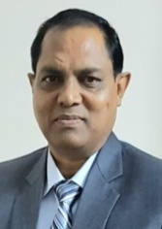
A Farewell party was organised at SIHFW on 26.11.2025 to felicitate SIHFW Director Dr S.S. Agrawal sir, on completion of his tenure with SIHFW and also on superannuation from Department of Medical and Health.
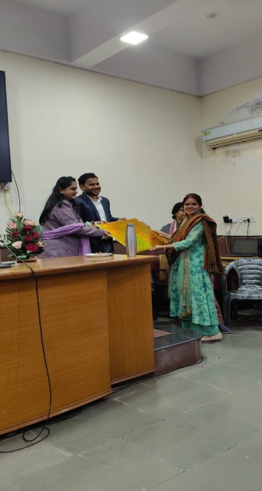
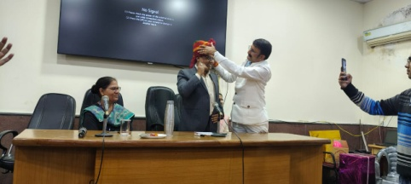

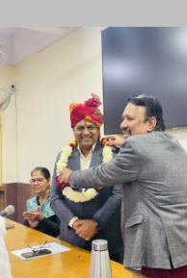
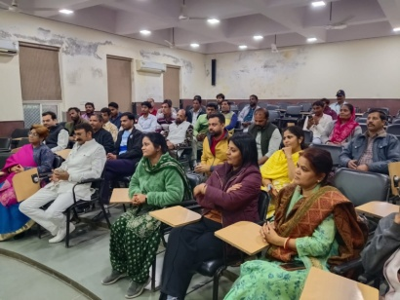
Workshops at SIHFW
National Workshop on Strengthening Capacity on Quality Palliative Care
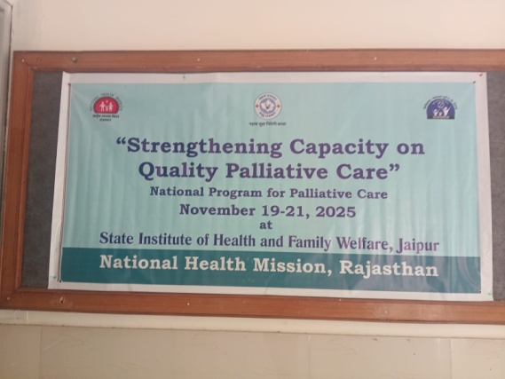
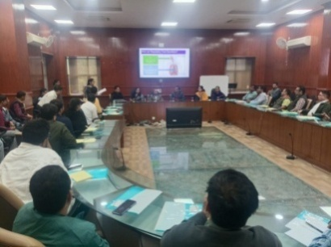
This was a 3 days workshop organised by NHM –Rajasthan in coordination with SIHFW. This workshop was organised on November 19 to 21, 2025. There were 28 participants including Specialists, SMOs and MOs. Out of 28, 10 participants were from other states of the country- Haryana, Gujarat, Bihar and Uttarpradesh. This was a capacity building workshop and on first day classroom sessions were organised and in other two days hands-on sessions were organised at centre for palliative care and medicine, SMS Medical College and Hospital, Jaipur. Key topics covered in this training workshop included Objective and Goal of NPPC, Management of Respiratory Symptoms, Palliative Care Emergencies, Assessment of Pain, Strong Opiods for cancer pain management, End of Life care, Management of GI symptoms, Communicating effectively, Diet and Nutrition, Record Keeping, Home based care and Home based care model of Rajasthan, Morbidity and data in NPPC. There were discussion and demonstration on management of wounds, ostomies and oral care.

Trainings at SIHFW
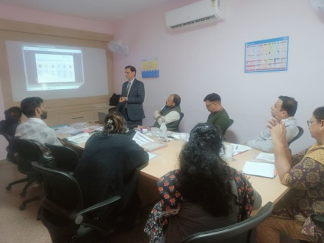
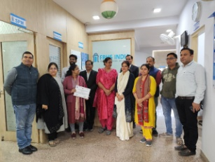
Training of Trainers (ToT)
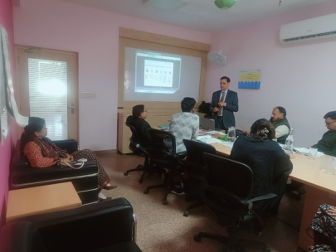
ToT on LS was organised in coordination with SIHFW at FRHSI. The training batch was monitored and hand holding was done by Dr Rajni Singh from SIHFW. This batch was organised on December 8 to 10, 2025.

Trainings on PLA

ToT on PLA
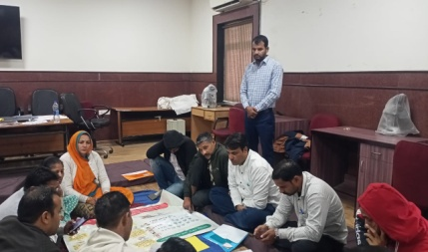
This ToT is organised on Participatory Learning in Action (PLA). This training is organised at SIHFW with technical support of Ekjut. Participants will organize PLA sessions at field level involving community members and field functionaries.
Role plays are organised on VHSNC meetings and Community Meetings. These dummy meetings are organised on various themes such as PLA, Identification of problems and preparing strategies, Family Planning, Safe Abortion, Nutrition, etc. Till December, one batch of State ToT was organised on Phase –V focused on Immunization and Child Health. 6 District level trainings are also organised at SIHFW. BHS, PHS and CHOs are participants in these trainings.
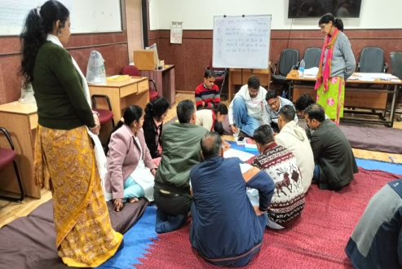
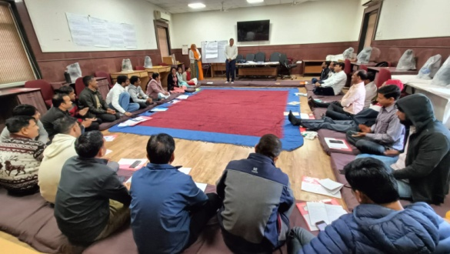

Foundation training of Newly Recruited Medical Officers
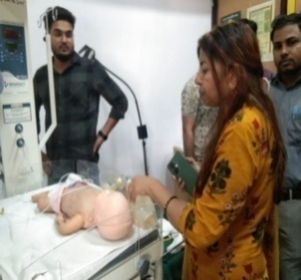
This is a 12 day training provided to newly recruited Medical Officers. Objective of this training is to orient the newly recruited MOs to learn about the various health programmes and schemes, latest guidelines, Acts, rules and regulations and government procedures, which they have to perform as a Medical officer. The training focuses on sharpening administrative skills of MOs along with clinical roles and responsibilities.

Participants were also taken on field visits to observe UPHC Gandhinagar for Quality Assessment and Certification Process. Participants are given hands on exposure in skill lab of SIHFW on various work stations and with dummies. Till December 5 batches of Foundation training were organised and 122 newly recruited Medical officers were trained in this training.

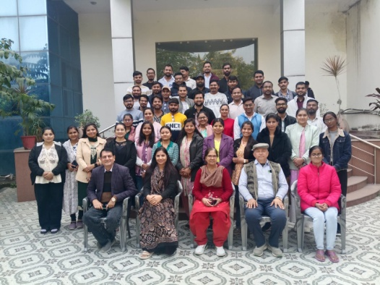
Trainings under Ayushman Bharat Program
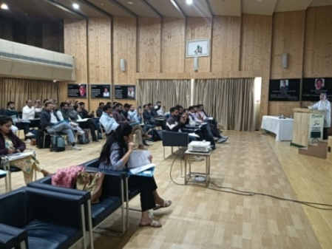
At present two types of trainings are being organised by SIHFW under Ayushman Bharat Program. CHOs Induction Training is organised for 15 days for newly recruited Medical Officers. These batches are being organised at SIHFW and few select districts. After this training, CHOs have to undergo 12 days training on Expanded Services (MNS, Elderly, Palliative, Oral, Eye, ENT and Emergency Care). These trainings are also planned at SIHFW and districts.
BSU training
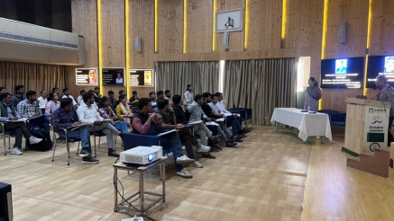
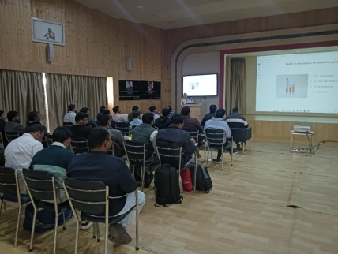
This training is organised for Medical Officers, Laboratory Technicians for duration of 3 days. It is organised by SIHFW at SDMH, Jaipur. Training methodology includes demonstration, clinical hands on practice, classroom. The trainings goal is to develop trained manpower of Medical Officers/LT for managing blood storage.

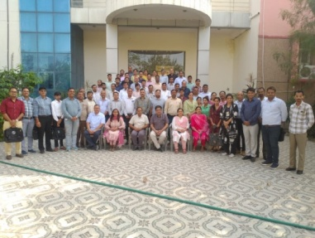
Quality Training

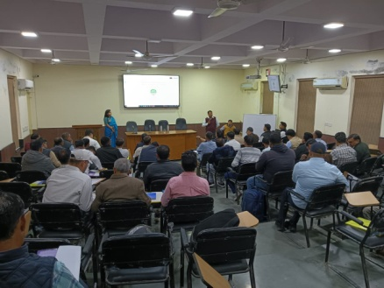

Training on Bio-Medical Waste

Trainings on Mental Health
Training under Mental Health Programme
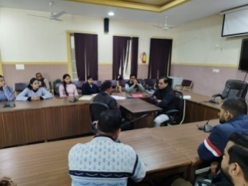
This is a 5 days training on NMHP and DMHP organised for Medical Officers at SIHFW. Key objectives of this training is to orient MOs on Understanding Mental Health, Identification, management and treatment of various Neurosis and Psychosis, non-pharmacological intervention, Telemanas. Participants are taken for exposure to Psychiatry centre at Jaipur for case presentations.
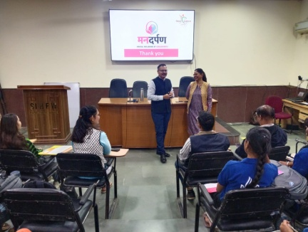
Felicitation of NSS Volunteers for Mental Health Week Activities
This activity was done in coordination with UNICEF . Those students who coordinated some activities during Mental awareness week, were felicitated with certificates.

Trainings under Immunization Program

Routine Immunization Training for Medical Officers
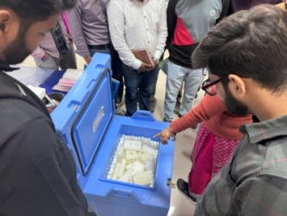
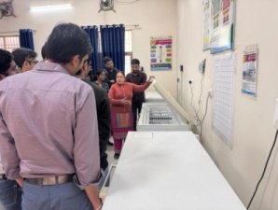
Routine Immunization training is of 3 days duration organized for Medical Officers at SIHFW. Training batches always scheduled such that first day of training is on Tuesday so that participants get an exposure visit of Routine Immunization session planned on Thursdays (MCHN day). Immunization schedule, AEFI, Cold chain, Vaccine Management etc are the components of this training. 17 batches were organsied at SIHFW and 250 participants were trained.

Orientation for BCMOs
Two days training –Orientation on Cold Chain for Block level Officials is organized at SIHFW. BCMOs and Medical Officers participate in this training. During last 3 months 10 batches were organised and 213 participants were trained in this training.

Trainings under NVBDCP

Training on Dengue and Chikunguniya

4 batches of this training were organised for Medical Officers at SIHFW and 144 participants were trained.

Training on Alpha Spray

This training was organised as a part of ICMR collaboration study on evaluation of the diagnostic accuracy in private clinics and diagnostics-a cross sectional study. 2 batches were organised during last 3 months and 51 participants were trained in these batches.

NPPC Training

Training on Palliative care is organised at SIHFW and exposure visits are arranged at Centre for Palliative Medicine and care at SMS Hospital, Jaipur. This training is of two categories-3 days training for Medical Officers and 6 days training for Nursing Officers. 16 batches are completed and 173 participants were trained.

Deafness training for Medical Officers

Screening training for deafness was organised at SIHFW for Medical Officers. 15 batches was organised and 556 Medical Officers were trained in this training.

Service Providers Training on National Quality Assurance Program (NQAS)
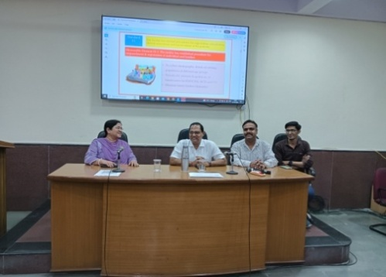
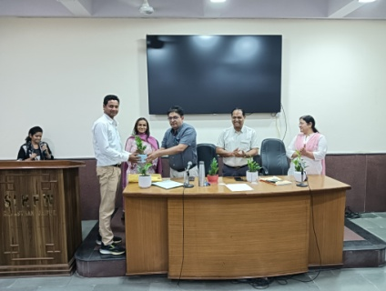
This is a 3- days training of service providers on National Quality Assurance Program, organised at SIHFW. Assessors, trainers participate at this training. This training is organized to develop knowledge of quality standards and assessments formats.

ASHA Refresher ToT training

ASHA Refresher ToT training is organized under ASHA Program. This is a six day training organized for refreshing knowledge of District ASHA trainers and mentoring and facilitation staff including ANM/SHS, etc. This training develops better supervision skills in facilitators to provide hand holding for ASHA workers. 4 batches were organised and 86 participants were trained.

Participation from SIHFW
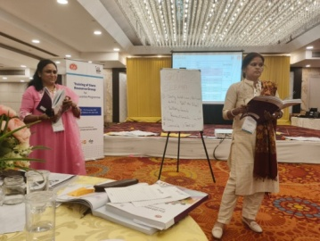
Training of State Resource Pool (SRP)

A five day national workshop on Training of SRP for Peer Educators was organised at Gaziyabad under RKSK program. It was organised on November 17 to 21, 2025. It was jointly organised by Ministry of Health and Family Welfare and UNFPA. Dr Ajapa Bhardwaj and Dr Rajni Singh from SIHFW participated in this training.
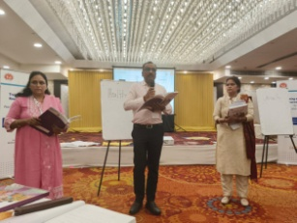
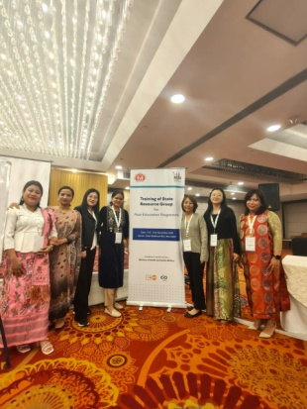
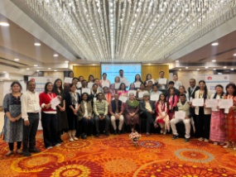

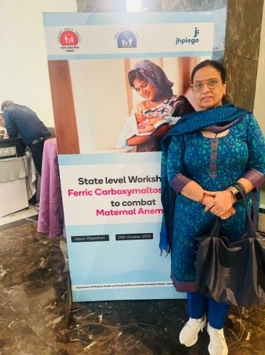
State Level Workshop on Maternal Anemia
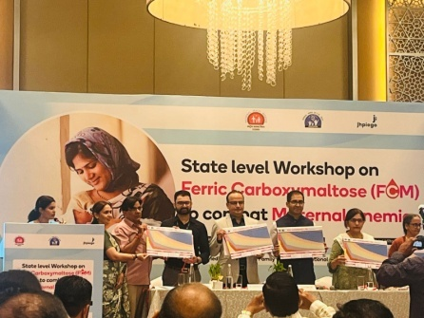
A wokshop was organised on use of Ferric Carboxymaltose to combat maternal anemia. It was organised on 29 October 2025. Dr Bharti Sharma, Faculty SIHFW represented the organization. It was organised by Jhpiego.
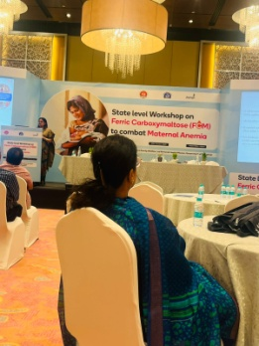

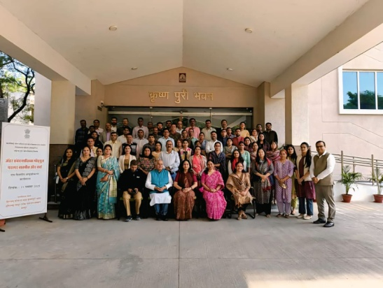
Participation at Day Gender Workshop
One day workshop on Gender Snsitization was organised at OTS, HCM-RIPA on 11.11.2025. Dr Ajapa, Archana and Dr Rajni participated from SIHFW.

Participation at Pravasi Rajasthani Diwas

State Government of Rajasthan organizes one day symposium on Pravasi Rajasthani Diwas, this year it was organised at JECC, Jaipur on December 10, 2025. Dr Suman Chaudhary, Mr Vikas Bhardwaj, Ms. Nishanka and Ms Archana participated at session on Health and Investment.

Health News

International News:
The World Health Organization (WHO) has validated Brazil for the elimination of mother-to-child transmission (EMTCT) of HIV, making it the most populous country in the Americas to achieve this historic milestone. This accomplishment reflects Brazil’s long-standing commitment to universal and free access to health services through its Unified Health System (SUS), anchored in a strong primary health-care system and respect for human rights.
“Eliminating mother-to-child transmission of HIV is a major public health achievement for any country, especially for a country as large and complex as Brazil,” said Dr Tedros Adhanom Ghebreyesus, WHO Director-General. “Brazil has shown that with sustained political commitment and equitable access to quality health services, every country can ensure that every child is born free of HIV and every mother receives the care she deserves.”
The milestone was marked during a ceremony in Brasília, attended by President Luiz Inácio Lula da Silva, Brazil’s Minister of Health Alexandre Padilha, and the Director of the Pan American Health Organization (PAHO) Dr Jarbas Barbosa, along with representatives from UNAIDS.
Brazil met all the criteria for EMTCT validation, including reducing vertical transmission of HIV to below 2% and achieving over 95% coverage for prenatal care, routine HIV testing, and timely treatment for pregnant women living with HIV. In addition to meeting the targets of the validation, Brazil demonstrated the delivery of quality services for mothers and their infants, robust data and laboratory systems, and a strong commitment to human rights, gender equality and community engagement.
The country implemented a progressive, subnational approach by first certifying states and municipalities with over 100 000 inhabitants, adapting the PAHO/WHO validation methodology to its national context while maintaining coherence across the country.
The evaluation, supported by PAHO, was conducted by independent experts who reviewed data, documentation, and health facility operations. Findings were then assessed by WHO’s Global Validation Advisory Committee, which formally recommended Brazil’s validation for elimination.
“This achievement shows that eliminating vertical transmission of HIV is possible when pregnant women know their HIV status, receive timely treatment, and have access to maternal health services and safe delivery,” said Dr Jarbas Barbosa, Director of PAHO. “It is also the result of the tireless dedication of thousands of health professionals, community health workers, and civil society organizations. Every day, they sustain the continuity of care, identify obstacles, and work to overcome them, ensuring that even the most vulnerable populations can access essential health services."
Over the past decade (2015-2024), more than 50 000 pediatric HIV infections have been averted in the Region of the Americas as a result of the implementation of the initiative to eliminate mother-to-child transmission of HIV.
Brazil’s success is part of the broader EMTCT Plus Initiative, which seeks to eliminate mother-to-child transmission of HIV, syphilis, hepatitis B, and congenital Chagas, in collaboration with UNICEF and UNAIDS. It is embedded within PAHO’s Elimination Initiative, a regional effort to eliminate more than 30 communicable diseases and related conditions in the Americas by 2030.
"I am delighted that Brazil has just been certified by WHO/PAHO for eliminating vertical transmission – the first country of more than 100 million people to do so,” said Winnie Byanyima, UNAIDS Executive Director. “And they did it by doing what we know works –prioritizing universal health care, tackling the social determinants that drive the epidemic, protecting human rights, and even – when necessary – breaking monopolies to secure access to medicines."
Brazil is one of 19 countries and territories worldwide that have been validated by WHO for EMTCT. Twelve of these are in the Region of the Americas. In 2015, Cuba became the first country in the world to be validated for EMTCT of HIV and the elimination of congenital syphilis. Other countries in the Region include Anguilla, Antigua and Barbuda, Bermuda, Cayman Islands, Montserrat, and Saint Kitts and Nevis in 2017; Dominica in 2020; Belize in 2023; and Jamaica and Saint Vincent and the Grenadines in 2024.
Source: WHO/18 December 2025

WHO highlights health risks and opportunities in the global waste crisis
Globally, the volume of municipal solid waste is growing at an unprecedented rate. Yet, many countries still lack the systems and resources to manage this waste safely.
“Solid waste reflects how our societies produce and consume, and how we treat people and the environment in the process,” said Dr Ruediger Krech, Director a.i., Department of Environment, Climate Change, One Health & Migration at the World Health Organization. “If we continue to treat waste as an afterthought, we will lock in avoidable disease, climate pollution and deep social inequities. This report is a clear call to put health and equity at the centre of how we design, manage and ultimately reduce waste.”
The report summarizes evidence on how solid waste – especially municipal solid waste – affects health through polluted air, water, soil and food. When waste is not collected, or is dumped, burned or not poorly treated, it can release hazardous chemicals, contaminate drinking-water sources and create breeding grounds for insects and rodents.
Communities underserved by waste management services, those living near dumpsites and poorly managed landfills and incinerators, children and pregnant women, as well as waste workers – particularly those working informally – face the greatest risks.
For the water, sanitation and hygiene (WASH) community, the report underlines that safe management of municipal and health care waste is integral to safely managed, climate-resilient systems.
A large share of municipal solid waste is still not collected or is disposed of in uncontrolled conditions, including open dumpsites and open burning. These practices damage ecosystems, contribute to climate change and undermine efforts to build healthy cities.
When waste is properly managed, however, it can become a resource – generating energy and creating green jobs. The report calls for a coordinated, multisectoral response grounded in the waste hierarchy: preventing waste where possible, then reducing, reusing and recycling, with safe recovery and disposal.
Key actions for governments and partners include reducing waste generation at source; expanding affordable and reliable waste collection services, especially in underserved communities; improving control at recovery and disposal facilities; and eliminating open dumping and burning, including hazardous waste.
The new report identifies a central role for the health sector in addressing solid waste as a public health threat. The health sector can prevent and minimize health-care waste at source, improve segregation and safe treatment, invest in cleaner climate-resilient technologies, and advocate for health-protective policies and standards. The report also encourages more surveillance, research and biomonitoring to strengthen the evidence base, and promotes social protection and inclusion of informal waste workers.
“This report gives countries and health authorities a very practical agenda,” said Mr Bruce Gordon, Head, Water, Sanitation, Hygiene and Health Unit, WHO. “Health ministries can start now by ensuring safe management of health-care waste, developing strong occupational health programmes for waste workers, and working with municipalities to reduce health risks from solid waste by closing open dumps and burn sites and gradually improving towards safe services. These concrete steps save lives today and will make cities cleaner and healthier in the future. Source: WHO/16 December 2025

National News:
Artificial Intelligence (AI) to drive transformative change in public health services
The Ministry of Health and Family Welfare is leveraging artificial intelligence (AI) to drive transformative change in public health services across India. The Ministry of Health has designated AIIMS Delhi, PGIMER Chandigarh and AIIMS Rishikesh as ‘Centre of Excellence (CoE) for Artificial Intelligence’ with an aim to promote development and use of AI-based solutions in Health.
The Ministry has collaborated with key organizations such as the Central Tuberculosis Division, National Centre for Disease Control, CDAC-Mohali, ICMR, MeitY, Ministry of Higher Education, Indian Institute of Science (IISc), and National Health Systems Resource Centre for a variety of AI projects. The Ministry has also collaborated with Wadhwani AI to provide technical support to the three COEs. The Ministry has developed AI solutions, including the Clinical Decision Support System (CDSS) in e-Sanjeevani, a Diabetic Retinopathy (DR identification solution), and the Abnormal Chest X-ray Classifier Model, among others.
MadhuNetrAI (DR identification solution) is an AI solution developed to enable non-specialist health workers to conduct screenings for Diabetic Retinopathy. It automates DR detection by analysing retinal fundus images using artificial intelligence, ensuring standardized, accessible, and efficient triage. It classifies DR across standard grades, enabling optimized resource allocation by prioritizing urgent cases for specialist referral. The solution has been implemented across 38 facilities in 11 states and provided AI assistance during screening of more than 14,000 retinal images, benefiting 7,100 patients.
The ‘Clinical Decision Support System’ (CDSS) AI solution has been integrated into the national telemedicine platform, eSanjeevani, to enhance consultation quality by streamlining patient complaints entry and providing AI-based differential diagnosis recommendations. Since CDSS integration in April 2023 till November 2025, 282 million eSanjeevani consultations have benefited from standardized data capture, ensuring consistency across health and wellness centres.
Under the Tuberculosis elimination program, ‘Cough against TB’ (CATB) AI solution is used for screening for pulmonary TB in the community settings. In the deployed geographies, the solution has shown an additional yield of 12-16% in TB reported, over patient screenings using conventional methods. Between March 2023 and 30th November 2025, CATB solution has been utilized to screen more than 1.62 lakh individuals.
Strict adherence to applicable standards and government policies, including AI Governance Guidelines by MeitY, Ethical Guidelines for Application of AI in Biomedical Research and Healthcare by ICMR, Information Technology Act 2000, Digital Personal Data Protection Act 2023, and Rules framed thereunder, and Information Security Policy for Healthcare by the Department of Health and Family Welfare, ensures high operational reliability. Source: Press Information Bureau/Dec 5, 2025

Simplification in Corneal Transplantation Rules to Boost Cornea Donation and Transplantation Services
The Ministry of Health and Family Welfare in alignment with the Government’s vision to promote equitable access to organ and tissue transplantation services has notified the Transplantation of Human Organs and Tissues (Amendment) Rules, 2025 under the Transplantation of Human Organs and Tissues Act, 1994 on 6th November, 2025.
This amendment which further strengthens the National Organ Transplant Programme (NOTP), aims to streamline the functioning of corneal transplantation centres and facilitate wider accessibility to eye donation and transplantation services across the country.
The mandatory requirement of the Clinical Specular equipment in Corneal Transplantation Centres has now been removed under this amendment. This change has been introduced after careful consideration of expert recommendations and stakeholder consultations. The amendment is expected to ease infrastructural and operational challenges, particularly for smaller eye centers in rural and semi-urban areas, thereby enhancing the overall availability and accessibility to the corneal transplantation services in the country.
This progressive amendment will serve as a long-term measure to strengthen the country’s cornea donation and transplantation ecosystem. Source: Press Information Bureau, 10 November 2025

We solicit your feedback:
Editing and Compilation by: Archana Saxena, JTA; IT support: Mohit Dhonkeriya;
Mentored by: Dr Bharti Sharma, Faculty-Gynaecology, SIHFW
State Institute of Health & Family Welfare
Jhalana Institutional Area, South of Doordarshan Kendra Jaipur (Raj)
Phone-2706534
E-mail:-sihfwraj@ymail.com; Website: www.sihfwrajasthan.com

